
Focus Brain Therapy
June 15, 2026
Concept/Mockup – Client Feedback – Learn More Content
Received from Marcy via email

Existing Client website: https://focusbraintherapy.com/
Concept/Mockup: https://focusbrain-kappa.vercel.app/

General questions from client: (Refer to their existing site)
- Is it possible to make the font bigger throughout please? The size of the font on the
old website was bigger and easier to read. Our clients have cognitive issues and
small font will prove difficult for them.
- In the section with the video, is it possible to make the background color white
instead of blue? Which means the text color will need to be black or dark blue in
order to be read. It also means the banner across the top with the tabs needs to be a
different color — perhaps pale blue — for contrast.
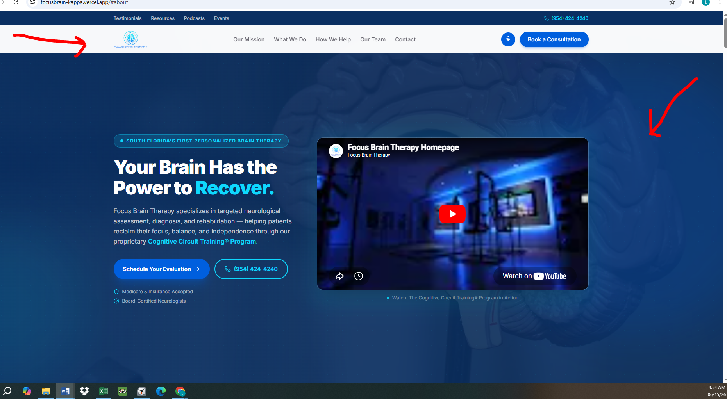
3. Remove the words ‘board-certified’ wherever they appear
4. Make their logo bolder, brighter, larger in all places.
HOME
Remove:
- The blue band across the top with the tabs: Testimonials, Resources, Podcasts and Events.
- The phone number from the top right-hand corner.
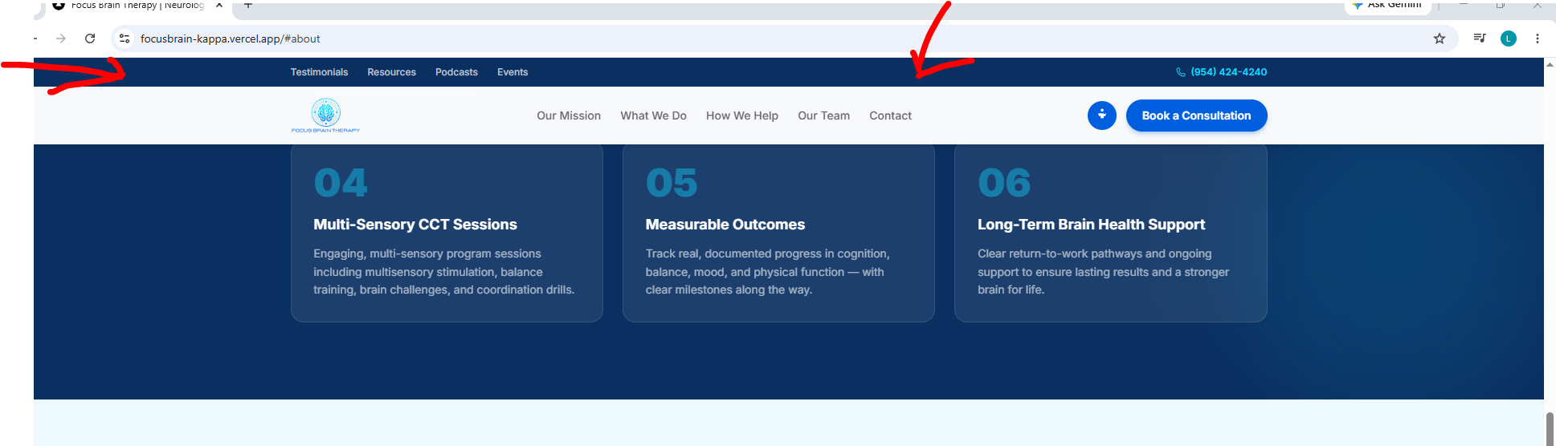
3. Change text to:
- Replace ‘South Florida’s First Personalized Brain Therapy’ with: Build a Better Brain (NOT all caps just the letters that are capitalized)
- Change the Title of the paragraph from ‘Your brain has the power to recover’ to: Your brain has the power to heal, recover and improve. (No capitals except the first letter of the first word.)
- Change the paragraph to: Focus Brain Therapy combines neurological assessment, rehabilitation, and enhancement through its proprietary Cognitive Circuit Training® program.
- Change Schedule Your Evaluation to button to: Schedule Your Free Evaluation
- Remove: Board-Certified Neurologists
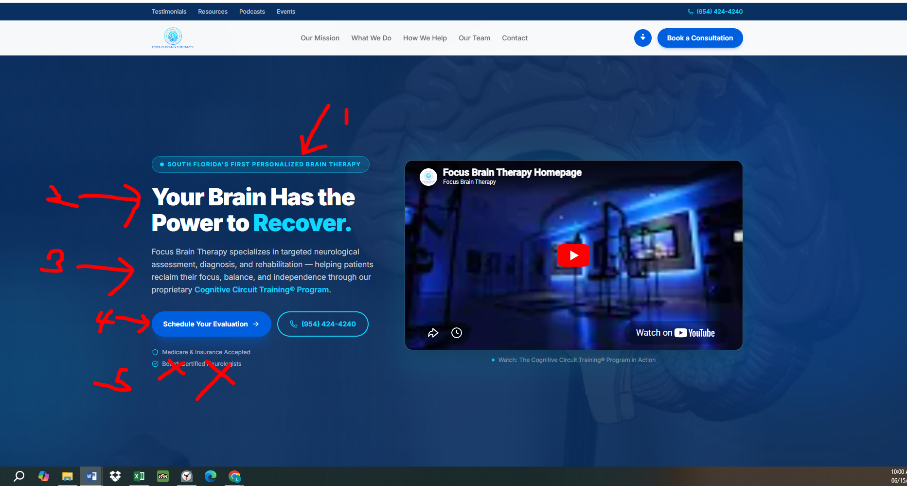

MENU
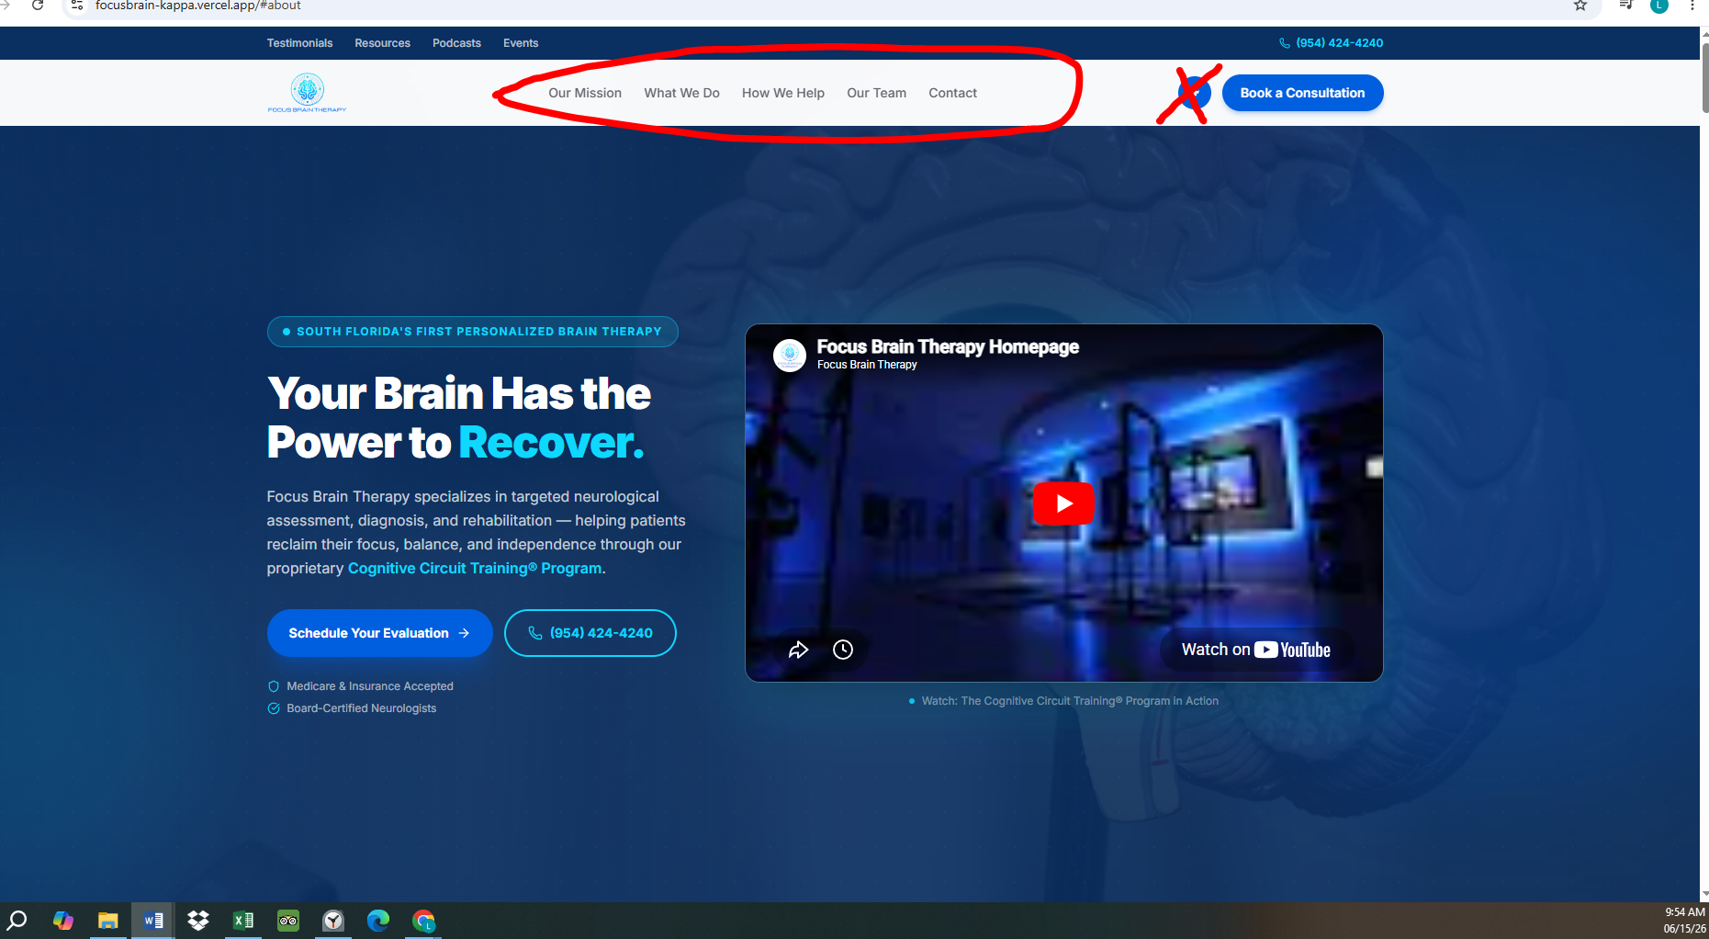
Change the tabs to the following (in the order listed below):
- What We Do
- Who We Help
- Testimonials
- Our Team
- Podcast
- Contact
In the far-right hand corner, remove the round blue circle and keep: Book a Consultation

COVERAGE & BILLING
Move this section under Patient Stories and Above Contact us at the very bottom of the page.
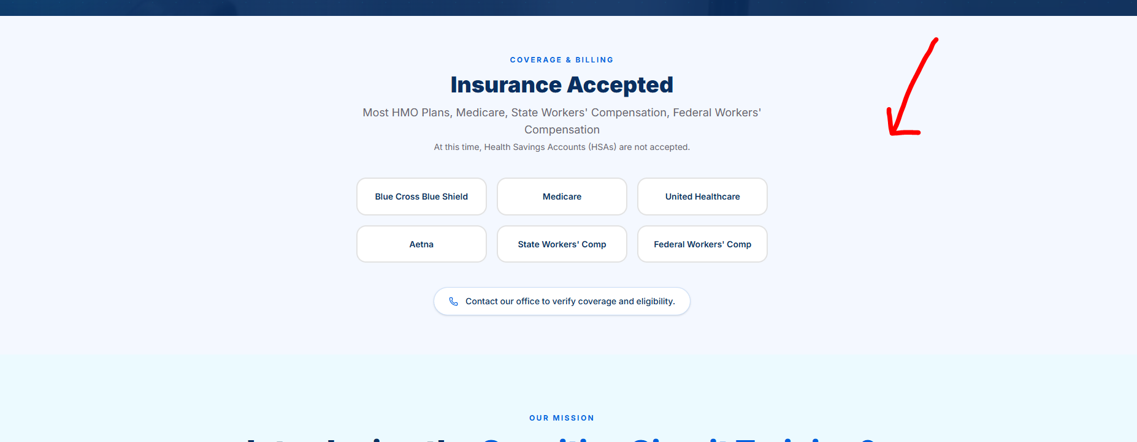
New placement location:
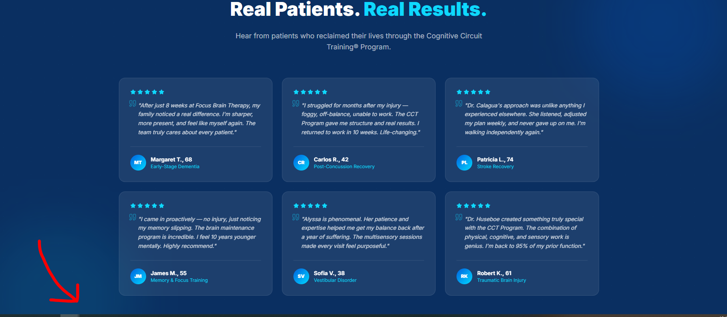

OUR MISSION SECTION
- Remove the words: OUR MISSION
- Under: Introducing the Cognitive Circuit Training® Program change the text to:
Our team of medical professionals and therapists will design an individualized, holistic
program to address your specific cognitive concerns. We look forward to working with
you and your family to help you build a better brain for a better life!
- In the box next to the photo, change the text to:
CCT is based on the latest cutting-edge research in neuroscience and cognitive
resilience. It integrates physical activity, cognitive exercises, sensory integration, and
emotional regulation to promote neuroplasticity, stimulate recovery, and optimize brain
function.

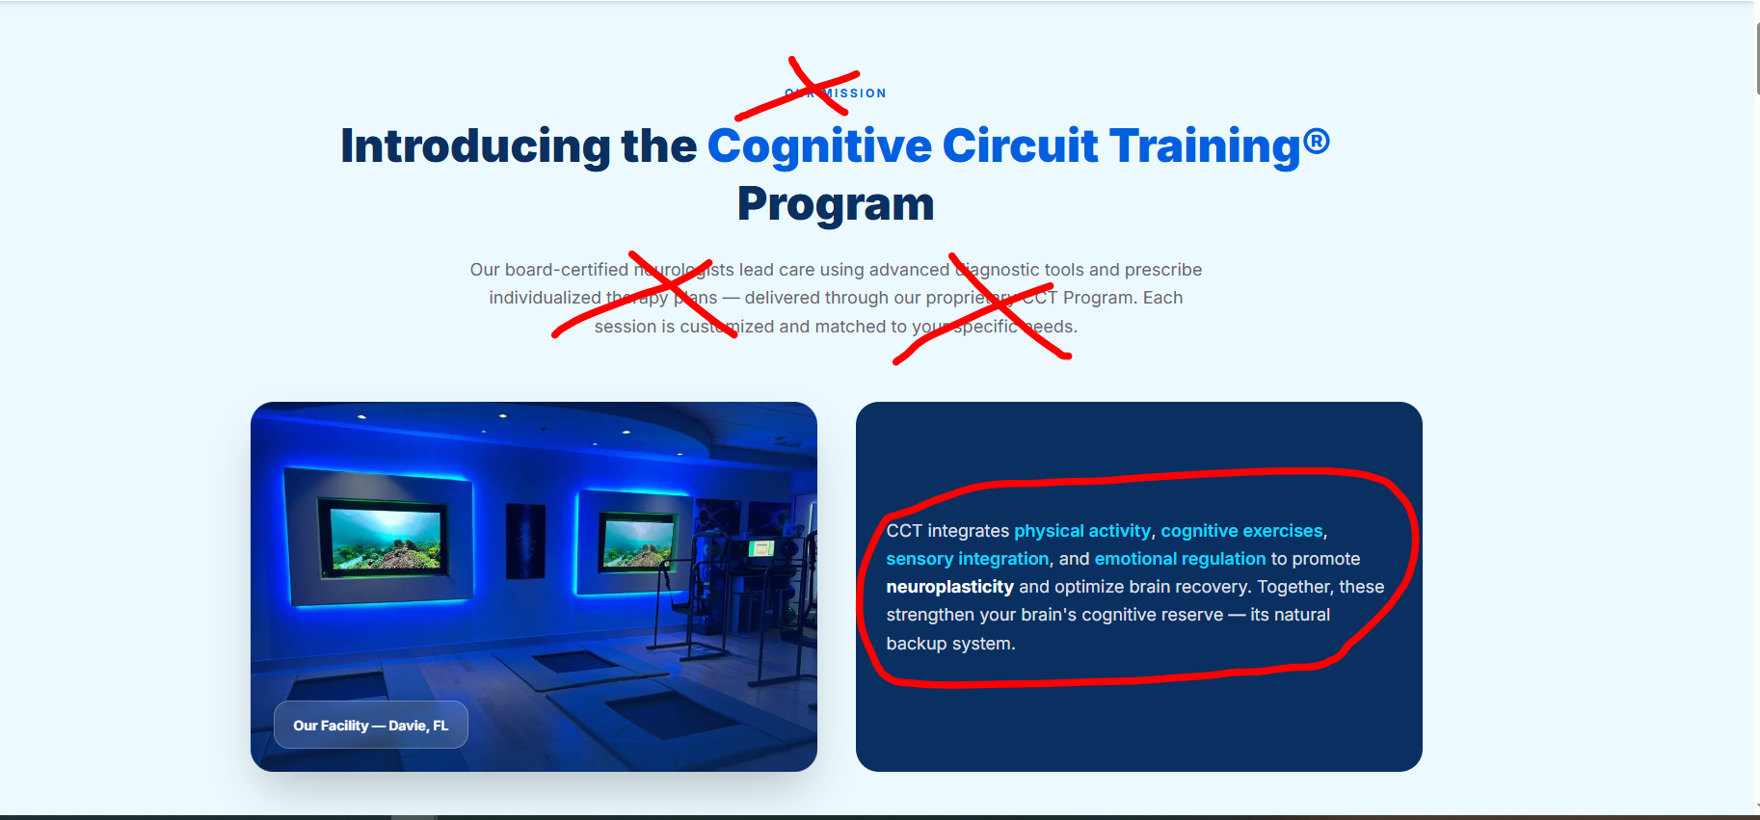

HOW WE HELP
- Remove the words: HOW WE HELP
- Remove capitals from Our Team Is Here for You and make it one sentence:
Our team is here for you — whether you’re recovering from an injury or proactively
supporting your brain health.
- Remove the entire pale blue band containing: Flexible Payment Options

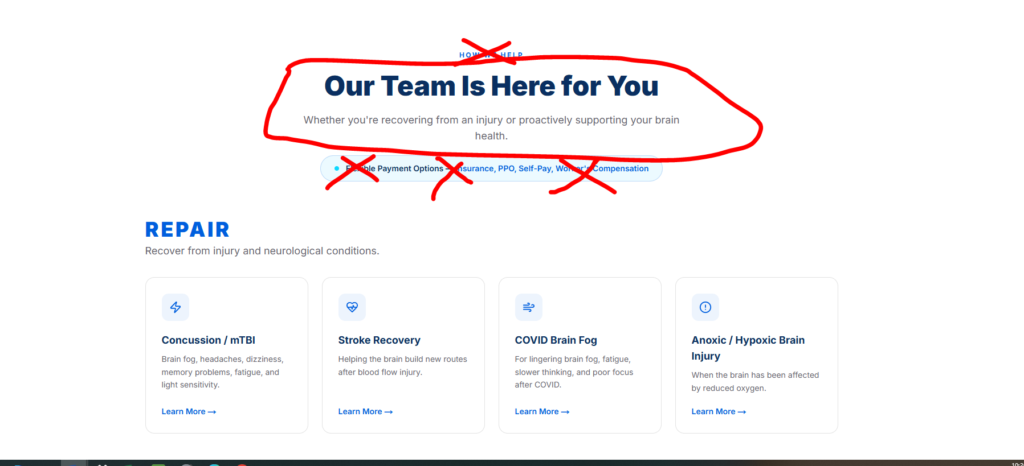

Remove the entire blue box containing: Do you worry about getting Dementia or
Memory Loss?
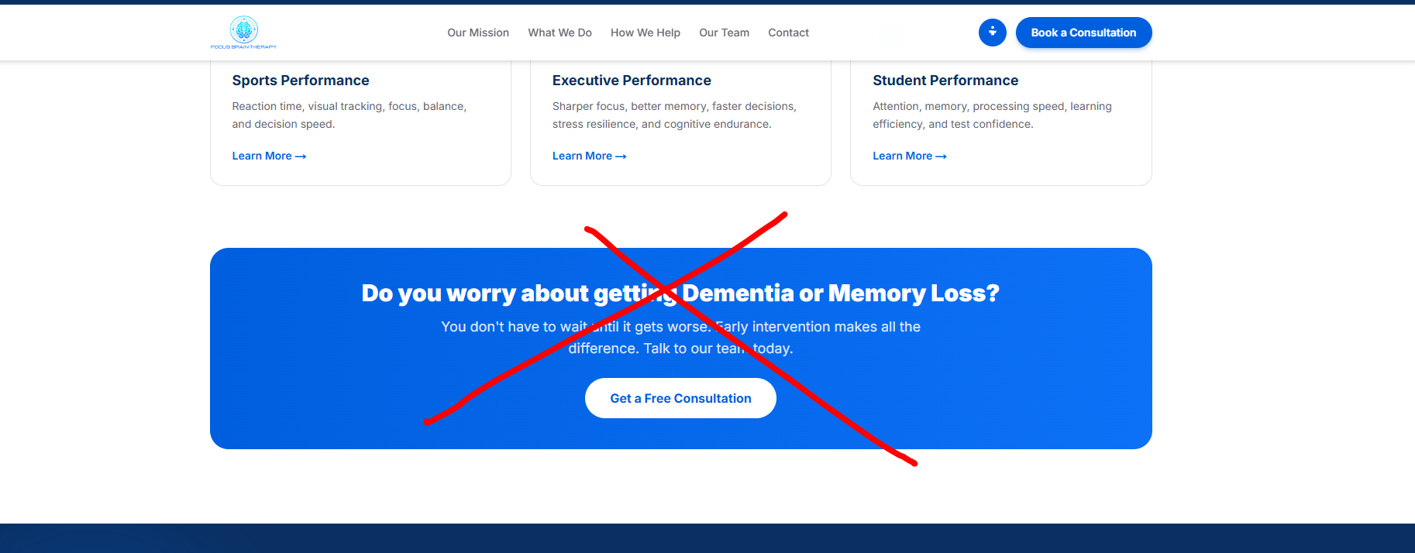

WHAT WE DO
- Remove the words: WHAT WE DO
- In box 01 Comprehensive Neurological Evaluation, replace the text with: Our doctors perform comprehensive diagnostic testing to understand your unique condition and baseline function.
- In box 02 Customized Therapy Plan, replace the text with: We build a personalized Cognitive Circuit Training® plan around your clinical findings, personal goals and lifestyle.
- In box 03, Expert-Monitored Treatment, replace the text with: We monitor your progress at every step of your recovery journey, and fine tune as needed.
- In box 04, Multi-Sensory CCT Sessions, replace the text with: You will enjoy our engaging, multi-sensory program sessions, which include visual, auditory, olfactory and tactile stimulation integrated with balance training, brain challenges, and coordination games.
- In box 05, Measurable Outcomes, replace the text with: We track your impressive progress in cognition, balance, mood, and physical function — with clear milestones along the way.
- In box 06, Long-Term Brain Health Support, replace the text with: We provide clear return-to-work pathways and ongoing support to ensure lasting results and a stronger brain for life.

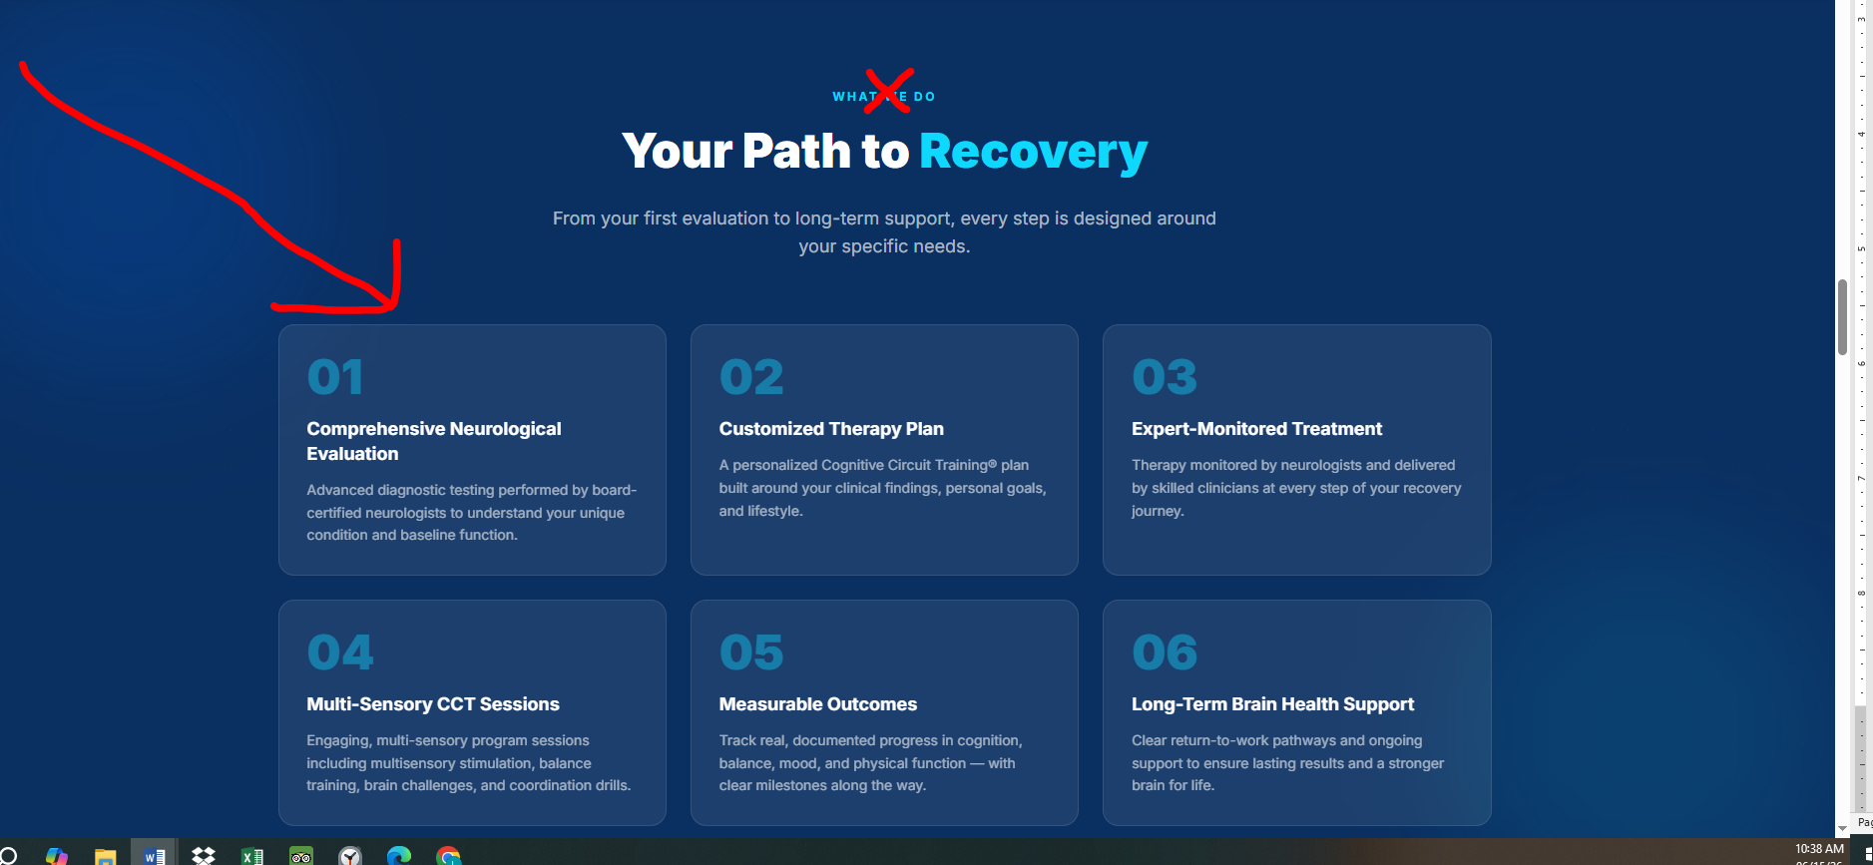

OUR TEAM SECTION
- Remove the words: OUR TEAM
- Change title Meet our providers to: Meet our passionate team
- Add new text under title: We bring together decades of experience in neurological rehabilitation and optimization of brain performance.
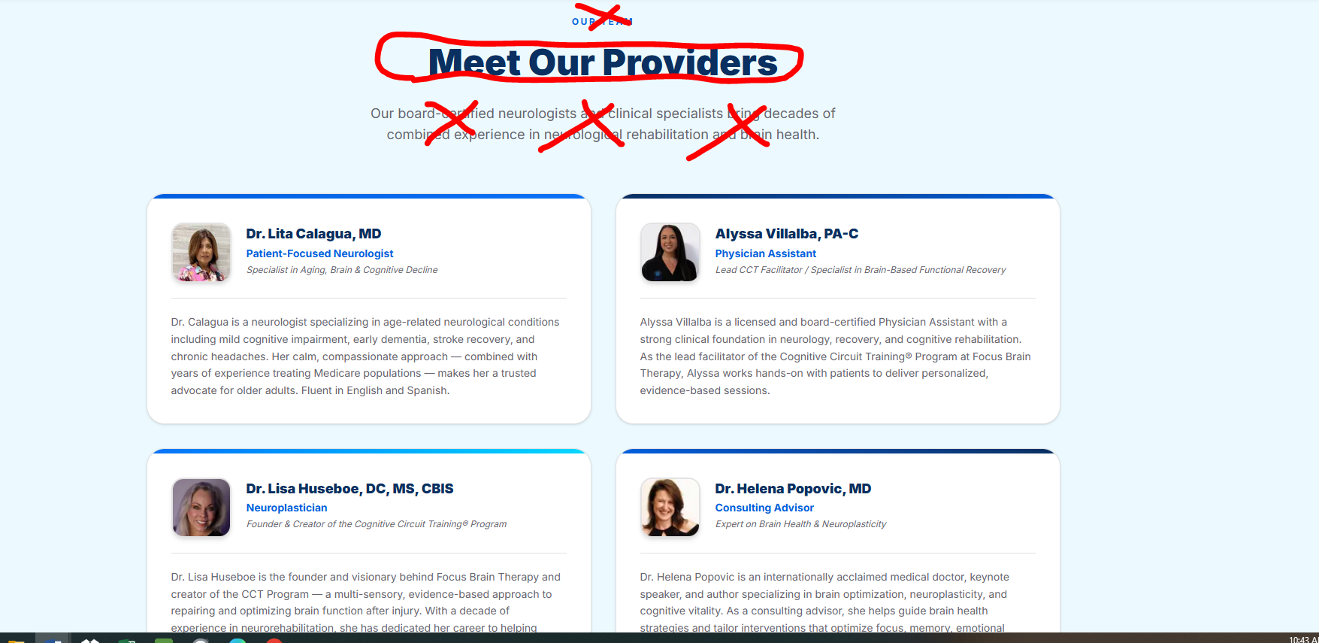

Dr. Helena Popovic, MD
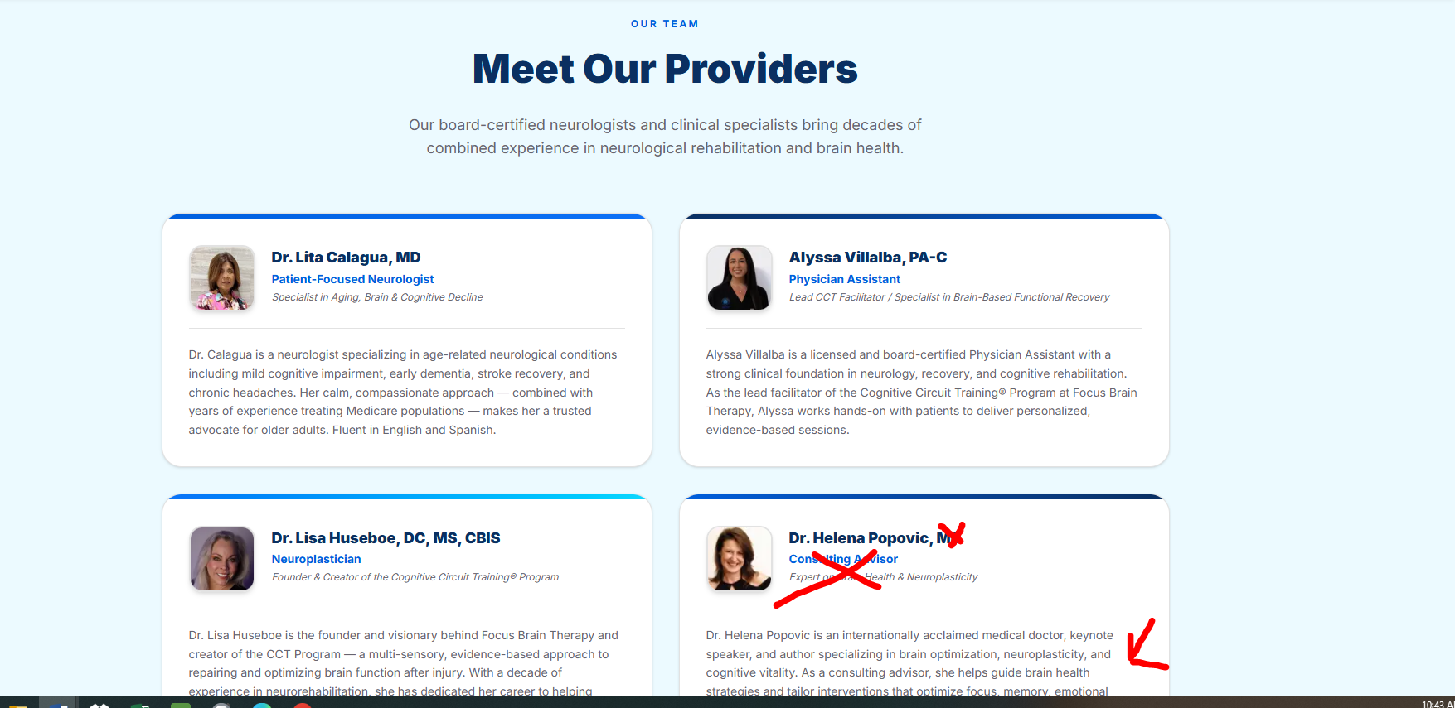

- Change the letters after Dr. Helena Popovic to: MBBS
- Change the words under Dr. Helena Popovic to: Consultant Advisor
- Change this text under title to: World-leading authority and best-selling author on brain health
- Change the bio for Dr. Helena Popovic to the following:
Dr. Helena Popovic obtained her Bachelor of Medicine and Surgery (MBBS) from the University of Sydney in Australia, and has been paving the way for a new paradigm in enhancing brain function through neuroplasticity for over three decades. Her philosophy is that education is more powerful than medication, and she believes in growing bolder rather than older. As our consultant advisor, she helps guide brain health strategies and tailor interventions that optimize focus, memory, emotional balance, and long-term resilience.
WHY CHOOSE US
- Remove the words: WHY CHOOSE US
- Add the word Choose in the title: Why Choose Focus Brain Therapy
- Change text underneath to: We combine the latest science with cutting-edge technology and compassionate care to deliver transformational results.
- Change the box: Board-Certified Neurologists to:
- Replace the text with: Our doctors really care! They are excited to be at the forefront of a medical revolution that is healing and enhancing brains and lives, in a way that seemed impossible only a few decades ago.
- Remove the entire dark blue band with the numbers.
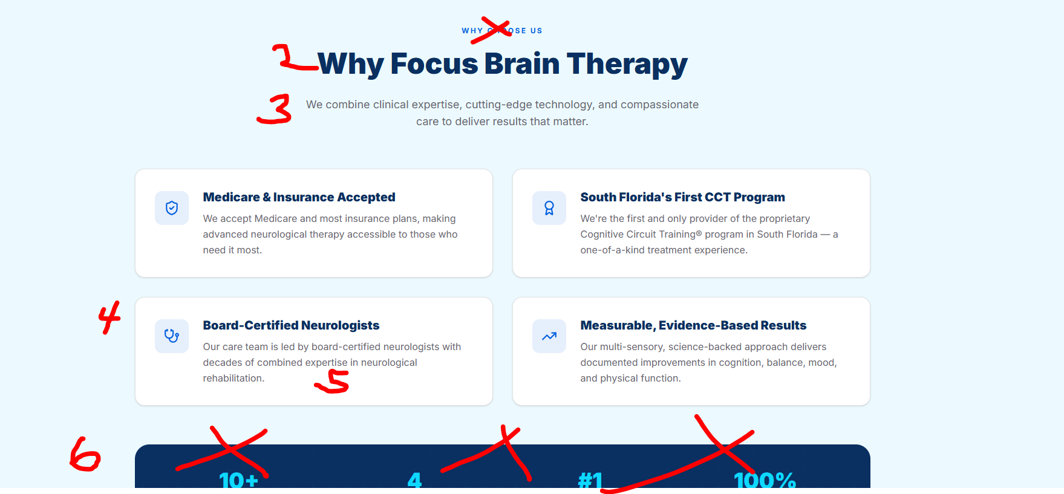

BOOK A CONSULTATION BUTTON
Add the word free to: Book Your Free Consultation
Change it all places.
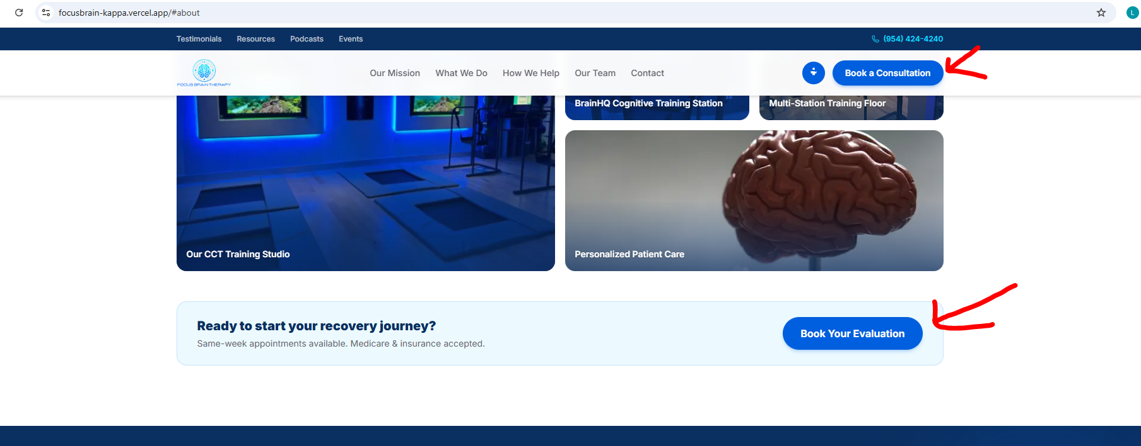
Remove this text.
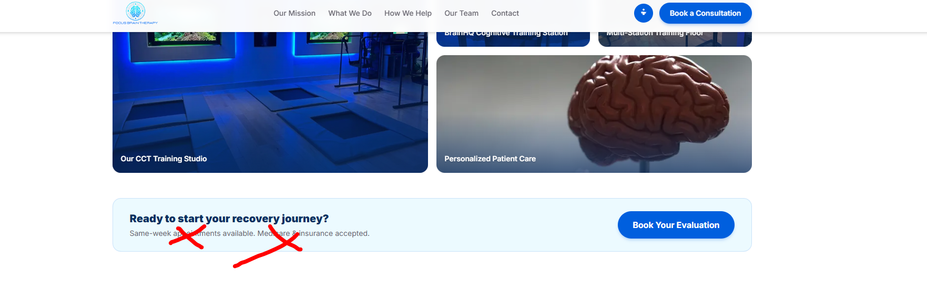
COVERAGE AND BILLING
This section was to be moved Under the Testimonial boxes and before the CONTACT US section.
Remove the title and add the add the following paragraphs: (include the bullets) before Insurance Accepted.

We help people:
- Recover from strokes, concussions and traumatic brain injuries
- Overcome brain fog in menopause and long COVID
- Improve executive function and focus in ADHD
- Enhance their memory, concentration, and overall brain performance
- Protect their brain from Parkinson’s, Alzheimer’s and other dementias
Straight under this we need the heading: WHO WE HELP with the following text underneath: (include bullets):
- Have you ever had a concussion, traumatic brain injury, or stroke?
- Have you been diagnosed with CTE (Chronic Traumatic Encephalopathy)?
- Do you have ADHD?
- Are you suffering from ‘long COVID’?
- Are you approaching or going through menopause and experiencing brain fog?
- Do you feel that you aren’t as sharp as you used to be?
- Are you worried about getting dementia or memory loss?
- Have you been diagnosed with Parkinson’s disease, mild cognitive impairment (MCI), Alzheimer’s disease or another type of dementia?
- Have you been told that your condition is incurable, and your brain function will continue to decline?
We’re here to show you that regardless of your symptoms or your diagnosis, it’s never
too late to turn things around. Your brain has the power to heal, recover and improve,
through the revolutionary science of neuroplasticity.
Right after the above paragraph it would be Insurance Accepted.
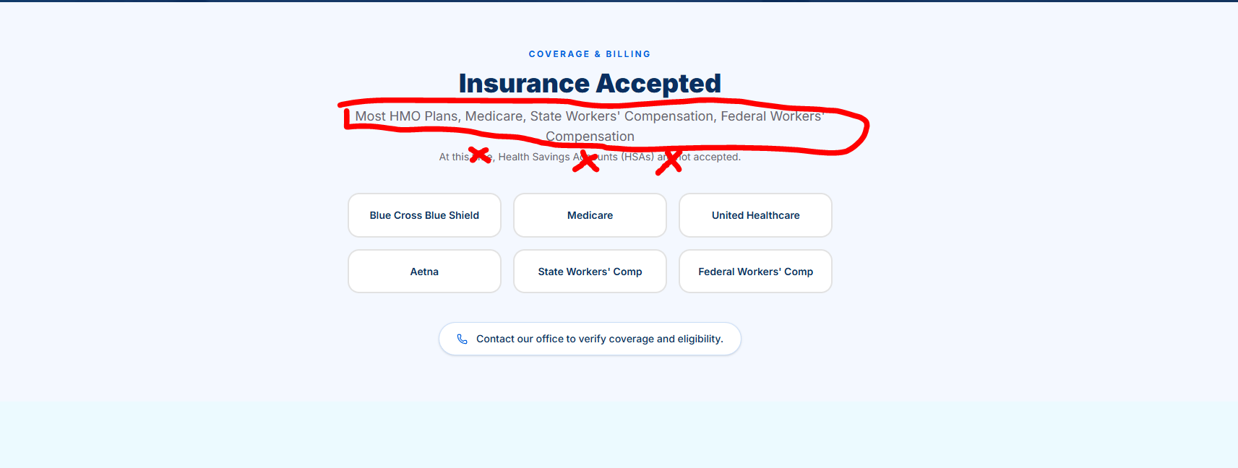
Change the text under Insurance Accepted to: Most PPO Plans, Medicare, State Workers’ Compensation, Federal Workers’ Compensation
Remove the sentence: At this time, Health Savings Accounts (HSAs) are not accepted.

CONTACT US SECTION
Replace the sentence: Reach out to schedule a consultation or ask us anything with: Schedule a free consultation. Our team is here to guide and coach you every step of the way.
Under Send Message, remove the sentences: We accept Medicare and most insurance plans. No obligation.
